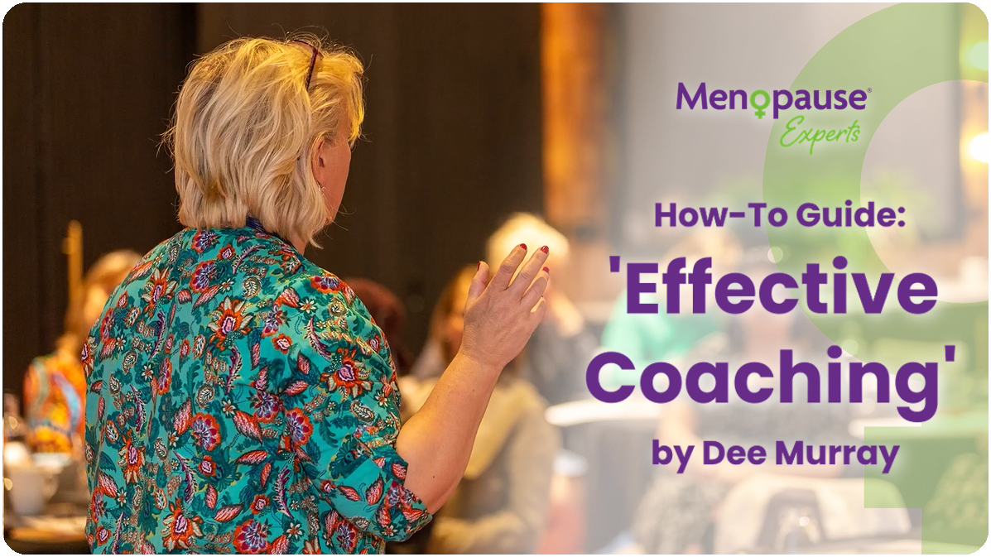

Module 1: Foundations of Effective Coaching in Women's Health

Objective: Lay the groundwork for effective coaching, understanding the unique needs of women in various life stages.

1. Develop Empathy and Active Listening:
- Empathy: Cultivate a deep understanding of your clients' experiences by putting yourself in their shoes. Show genuine care and concern for their well-being.
- Active Listening: Practice attentive listening without interrupting. Reflect back to your client what they express, to demonstrate that you are fully engaged in their stories.

2. Stay Informed about Women's Health Issues:
- Continuous Learning: Attend conferences, read research articles, and engage in ongoing education to stay informed about the latest developments in women's health.
- Networking: Connect with healthcare professionals and specialists to exchange insights and collaborate on holistic women's health.

3. Build Trust and Rapport:
- Transparency: Be open and honest about your coaching process, what clients can expect, and how you can support them.
- Consistency: Demonstrate reliability in your coaching sessions, reinforcing a sense of safety and trust.

4. Understand the Intersectionality of Women's Experiences:
- Inclusivity: Recognize and honour the diverse backgrounds, cultures, and identities of your clients. Tailor your coaching approach to respect their unique experiences.
- Cultural Competence: Continuously educate yourself on different cultural practices and beliefs related to women's health.

5. Holistic Approach to Well-being:
- Integrated Coaching: Address physical, mental, and emotional aspects of well-being in your coaching conversations. Encourage clients to see their health as interconnected and multifaceted.
- Wellness Models: Utilize wellness models like the wellness wheel to help clients visualize and work towards a balanced life.

6. Encourage Goal Setting and Accountability:
- SMART Goals: Guide clients in setting Specific, Measurable, Achievable, Relevant, and Time-bound goals. Break down larger goals into smaller, achievable steps.
- Regular Check-Ins: Establish a system for regular check-ins to review progress, celebrate successes, and address any obstacles.

7. Empowerment Through Education:
- Informative Resources: Provide educational materials that empower clients to make informed decisions about their health.
- Discussion: Encourage open discussions about various health topics, offering your expertise to clarify any questions or concerns.

8. Cultivate Resilience and Coping Strategies:
- Strengths-Based Approach: Focus on identifying and leveraging clients' strengths to navigate challenges.
- Mindfulness Practices: Introduce mindfulness and stress reduction techniques to build emotional resilience and enhance overall well-being.

9. Networking and Collaboration:
- Professional Connections: Build relationships with healthcare professionals, therapists, and experts in women's health for collaborative efforts and referrals.
- Community Engagement: Join women's health forums, attend events, and participate in initiatives to expand your network and stay connected.

10. Stay Adaptable and Responsive:
- Flexibility: Adapt your coaching approach based on client feedback and evolving needs.
- Continuous Improvement: Engage in reflective practices and seek feedback to continuously improve your coaching skills and effectiveness.

11. Self-Care for Coaches:
- Balanced Lifestyle: Prioritize your own self-care to maintain physical and mental well-being. A coach who practices self-care is better equipped to support others.
- Supervision and Peer Support: Seek supervision or connect with peers for regular discussions about your coaching practice, fostering personal and professional growth.

Module 2: Setting Fees for One-on-One Coaching Sessions

1. Assess Your Expertise and Experience:
- Qualifications: Highlight your educational background, certifications, and any specialized training that enhances your expertise in women's health coaching.
- Unique Skills: Identify and emphasize any unique skills or approaches that set you apart in the coaching industry.

2. Research Market Rates:
- Competitive Analysis: Research the rates charged by other women's health coaches in your geographic area or target market.
- Industry Trends: Stay informed about trends and shifts in coaching fees within the women's health sector.

3. Define Your Service Offering:
- Scope of Services: Clearly outline the services you provide, including any additional resources, ongoing support, or personalized materials. Introduce a “value ladder” with different offerings so that clients have various options for working with you. This could range from a one-off taster session to a package of sessions.
- Value Proposition: Clearly communicate the unique value clients receive through your coaching services.

4. Consider Client Affordability:
- Target Market: Understand the financial capacity of your ideal clients. Align your fees with what they can reasonably afford.
- Value Perception: Ensure that clients perceive the value of your services in relation to the fees you charge.

5. Factor in Overhead and Business Expenses:
- Expense Assessment: List and calculate your business expenses, including marketing, website maintenance, and ongoing professional development.
- Profit Margin: Set fees that not only cover expenses but also allow for a reasonable profit margin.

6. Calculate Your Hourly Rate:
- Desired Annual Income: Determine your desired annual income.
- Coaching Hours: Estimate the number of coaching hours you can realistically provide in a week or month.
- Hourly Rate Calculation: Divide your annual income by the number of coaching hours to calculate your hourly rate.

7. Offer Package Deals:
- Package Components: Design packages that offer additional value, such as resources, check-ins between sessions, or exclusive materials.
- Discount Incentives: Encourage clients to commit to multiple sessions by offering discounted rates for package deals.

Module 3: Setting Fees for Events

1. Event Planning Costs:
- Venue and Logistics: Calculate costs associated with event logistics, including venue rental, materials, catering, and any guest speakers or experts.
- Marketing: Include expenses related to promoting the event, such as promotional materials and advertising.

2. Set a Base Fee:
- Hourly or Flat Rate: Determine whether your base fee will be a flat rate or an hourly rate for your time and expertise.
- Value Offered: Consider the overall value attendees will gain from the event in relation to the base fee.

3. Consider Attendee Benefits:
- Networking Opportunities: Highlight opportunities for attendees to connect with each other.
- Exclusive Resources: Include access to resources, materials, or expert insights as part of the overall benefits.

4. Calculate Your Total Fees:
- Add Up Costs: Total all event planning costs, including venue, logistics, marketing, and any additional expenses.
- Base Fee Addition: Add your base fee to the total event planning costs to determine the overall event fee.

5. Offer Early Bird or Group Discounts:
- Early Bird Incentives: Encourage early registrations by offering discounted rates for those who sign up well in advance.
- Group Rates: Provide discounts for groups or organizations registering multiple participants.

6. Customize for Corporate Events:
- Tailored Packages: Work with corporate clients to create customized packages based on the scale, duration, and specific needs of the event.
- Corporate Benefits: Highlight the specific benefits that corporate attendees will gain, such as team-building opportunities or professional development.

Disclaimer:
Coaching remains unregulated in the UK, allowing individuals to pursue a career as a life coach without specific regulatory requirements. It is important to note that while there is no legal restriction, we strongly advise against self-identifying as a coach without acquiring sufficient training or practical experience.

This section is intended to broaden your understanding of coaching and enhance your practice if you are already engaged in coaching. We emphasize the significance of obtaining adequate training and experience to provide effective and ethical coaching services. Professional development and continuous learning are essential components for those aspiring to be impactful coaches.

Engaging in coaching without proper preparation may limit your ability to effectively support clients and uphold the ethical standards expected in the coaching profession. Therefore, we encourage individuals interested in coaching to seek reputable training programs and gain practical experience to develop the necessary skills and knowledge.

By accessing this information, you acknowledge that coaching, in its unregulated state, requires a commitment to ongoing learning and ethical practice. The content provided here is intended to serve as a resource to open your mind to coaching concepts and strategies, fostering a proactive approach to bettering your coaching practice.

Should you choose to pursue a career in coaching, we recommend investing time and effort in acquiring the appropriate qualifications and skills to ensure you provide valuable and ethical coaching services.

MEG intends to offer an accredited life coaching course sometime in the future.

Copyright © 2024 Menopause Experts Group Ltd. All rights reserved. Unauthorized reproduction, distribution, or disclosure of this material, in whole or in part, is strictly prohibited.

